MT 184.1 SUSPENSIBILITY OF FORMULATIONS FORMING SUSPENSIONS ON DILUTION WITH WATER

SCOPE

This method is intended to determine the suspensibility which is defined as the percentage of one or more active ingredient(s) remaining in suspension after a given time. The method is applicable to formulations forming suspensions on dilution with water at sample concentrations between 0.1 % and 10 %.

REASONS FOR THE REVISION:

Sample preparation has been harmonized, temperature requirements have been changed from 30 °C to 25 ± 5 °C, the range of applicable concentrations has been set from 0.1 to 10% and the calculations for water soluble bags has been updated. The concept of performing a “Re-Suspensibility” was introduced as an extension of the method. Some editorially changes have been made and obsolete references have been removed. Where same conditions are used, results obtained with MT 184.1 are equivalent to those obtained with MT 184.

OUTLINE OF METHOD

A suspension of the formulation in Standard Water is allowed to remain undisturbed for a specified time at ambient temperature before the top 9/10ths are drawn off and the remaining 1/10th is assayed. The suspensibility is calculated as the percentage of particles remaining suspended.

REAGENTS

CIPAC Standard Water D, MT 18.1.4, unless otherwise specified
Water, deionised

APPARATUS

Measuring cylinders 250 ml with stopper, the distance between the graduations 0 ml and 250 ml should be between 20 cm and 26 cm, and should be between the 250 ml mark and the bottom of the stopper 3 cm to 7 cm (see Fig 1)
Suction tube or alternatively an U-shaped tube, both connected to a suitable source of vacuum (see Fig 1 and Fig 2).

Beakers of suitable sizes

Glass dish for drying of residues

Stopwatch
Analytical balance with an accuracy to measure 4 significant figures
Magnetic stirrer, 120 rpm to 1200 rpm
Magnetic stir bar, length preferably > 2 cm
Water bath or drying device capable of maintaining a temperature of 70 °C

PROCEDURE

(a) Dispersion of the test sample
All operations are performed at ambient temperature (25 ± 5 °C). Weigh the required amount of test sample (b in [g]) to make up 250 ml of a suspension in water and record the weight with an accuracy of three significant figures. The maximum deviation of the actual weight from the calculated weight must not exceed 10 % (Note 1).

(a1) Solid formulations
Some solid formulations require preparation of a smooth paste (pre-slurrying) before they disperse readily to form a suspension (Note 2).
Fill a beaker with approx. 50 ml Standard Water. Add the weighed test sample to the beaker and stir on a magnetic stirrer for 2 min followed by a standing time of 4 min. It is essential to make sure the test sample has completely dispersed (Note 3). Transfer the suspension quantitatively to the measuring cylinder using Standard Water. Proceed as per (b) Preparation of the suspension.

(a2) Solid formulations packed in water soluble bags
If the formulation is packed in water soluble bags, water soluble bag material must be dissolved in the Standard Water prior to adding the test sample and performing the suspensibility test (Note 4). Proceed as per (a1) Solid formulations.

(a3) Liquid formulations
Add approx. 100 to 200 ml Standard Water to the measuring cylinder. Either weigh the test sample into a beaker and transfer it quantitatively with Standard Water to the measuring cylinder or weigh it directly into the cylinder. Proceed as per (b) Preparation of the suspension.

(b) Preparation of the suspension
Make up the test cylinder to 250 ml with Standard Water and insert the stopper. Invert the cylinder 30 times (Note 5).

(c) Determination of sedimentation
Place the cylinder on a flat surface in an upright position free from vibration and protected from direct sunlight. Let it stand for 30 min. Then remove the top 225 ml (= top 9/10ths) using the suction tube. Take care that the tip of the tube is always only a few mm below the falling level of the liquid except in the latter stages when the liquid must not be withdrawn from below the 25 ml mark.

(d) Assay of the remaining 25 ml (1/10th)
The remaining 25 ml in the cylinder must be assayed in one of the following ways (Note 6):
(d1) chemically, by an appropriate analytical method for the active ingredient(s)
(d2) gravimetrically, by transferring the remaining 25 ml of the suspension quantitatively into a drying dish, rinsing the cylinder with deionised water, evaporating the water and drying the residue in the drying dish to a constant weight (Note 7).
For drying a temperature of approx. 70 °C is recommended. If the active ingredients (or formulation components) are not stable at this temperature a lower drying temperature should be used. The same temperature and conditions should be applied for drying the remaining 25 ml in the cylinder, the 25 ml of CIPAC Standard Water (Note 7) and the liquid formulations (Note 8).

(e) Calculation
Each of the following assay methods yields a mass:
- the chemical assay (e1) gives the mass of each active ingredient,
- the gravimetric assay (e2) yields the combined mass of non-volatile solids.
Using the mass obtained, calculate the suspensibility using the following equation.
Suspensibility [%] | $$= \frac{10}{9} × \frac{100 ×(c-Q)}{c} = \frac{111 ×(c-Q)}{c}$$ | where:

(e1) Chemical assay method:
c | = | a x b; total mass of active ingredient in the cylinder | [g]
a | = | content of the active ingredient (% w/w) in the formulation | [%]
b | = | mass of sample added to the cylinder | [g]
Q | = | mass of the active ingredient in the 25 ml remaining  in the cylinder | [g]

Calculate the suspensibility for each active ingredient individually.

(e2) Gravimetric assay method:
c | = | a x b = dry weight of the sample in the cylinder | [g]
a | = | dry weight ratio of the sample  - for liquid formulations see (Note 8)  - for solid formulations a = 1
b | = | mass of sample added to the cylinder | [g]
Q | = | d – e, true mass of dry residue of the bottom 25 ml | [g]
d | = | mass of dry residue of the bottom 25 ml | [g]
e | = | mass of dry residue of 25 ml of CIPAC Standard Water (Note 7) | [g]

(f) Re-Suspensibility, if required
If the suspensibility is below 60 % or above 105 %, a re-suspensibility test is required. In practice it is often found that spray mixtures can be easily re-homogenized by gentle agitation when the spray mixture was left unagitated for some time. To demonstrate the ease of re-suspensibility, an additional test shall be performed following the procedures (a) to (e) as described before. However, after the 30 min standing time of step (c), the suspension is not drawn off but the cylinder is inverted again 30 times (Note 5). After the last inversion the top 225 ml (= top 9/10ths) are immediately drawn off without any additional standing time. The re-suspensibility in the bottom 25 ml is then determined as described in (d) and (e) using the same assay method as before. Report both results of the suspensibility and the re-suspensibility test.

(g) Reporting
Report the suspensibility to the nearest 1 % together with the following parameters:
- test concentration
- Standard Water used
- assay method used
- weight ratio of the empty water soluble bag relative to the formulation in the
bag (if applicable)
- pre-slurrying (if performed)
- re-suspensibility (if performed)

Note 1 Unless otherwise specified the test should be performed at the highest and lowest recommended use rates if within the scope of the method. For use rates below 0.1%, it is recommended that the test be carried out at 0.1%. If performed at concentrations above 10 % misleading results may be obtained as sediments at levels exceeding 25 mL will be removed following the test procedure.
Note 2 With the help of a glass rod fitted at one end with a rubber bung, mix the test sample in a glass beaker with a small portion of Standard Water to prepare a smooth paste. Start with a water/test sample ratio of 1:1 and mix for at least 2 min. Make sure any lumps or agglomerates have completely disintegrated. Dilute with more Standard Water to disperse fully. Proceed with stirring for 2 min and the further sample preparation procedures as per (a1) Solid formulations.
Note 3 Some preparations may need longer time until fully dispersed. In such a case the stirring and standing time can be prolonged to 10 min.
Note 4 Dissolve the water soluble bag material in Standard Water according to the weight ratio of bag material to formulation. If the product is sold in a range of bag sizes use the highest ratio for this test. Determine the weight ratio (w _{B/F}) of the empty water soluble bag relative to the formulation in the bag, according to the following equation:
$${w }_{B/F} = \frac{B}{F}$$
where: |  |  |  |  |  | Example:
B | = | mass of the empty bag [g] |  |  |  | B = 0.9 g
F | = | mass of the formulation in the bag [g] |  |  |  | F = 30 g
Example: |  |  | $${w }_{B/F}=\frac{0.9 g}{30 g} =0.03$$

Either dissolve the bag material directly in the Standard Water (Note 4.1) or prepare a stock solution of the bag material (Note 4.2).

(Note 4.1) Direct dissolution: Dissolve a portion of the water soluble bag (M _{bag} in [g]) in Standard Water according to the following equation:
$${M }_{bag} [g]= {w }_{B/F} × b [g]$$
where: |  |  | Example:
M _{bag} | = | mass of the bag material [g]  to be added | M _{bag} = to be calculated
w _{B/F} | = | weight ratio of the empty  water soluble bag relative to  the formulation in the bag | w _{B/F} = 0.03
b | = | mass of sample added to  the cylinder | b = 5 g
Example:
$${M }_{bag} \left[g\right]=0.03 ×5 g= 0.15 g$$

(Note 4.2) Stock solution: It is recommended to adjust the concentration of this solution in a way that 10 to 25 ml of stock solution are used per test. Do not mix the stock solution directly with the test sample but dilute the stock solution first with Standard Water as per (a1) Solid formulations.
Example for preparation of a 1 % stock solution:
Dissolve approximately 1 g ± 0.1 g of the bag material in 100 ml Standard Water by stirring. Calculate the volume (V in [ml]) of the stock solution to be added to the Standard Water prior to performing the suspensibility test according to the following equation:
$$V \left[ml\right]= \frac{M_{ bag}}{c_{ Stock}} × 100$$
where: |  |  |  | Example:
V | = | Volume [ml] of the stock solution  to be added |  | V [ml]= to be calculated
M _{bag} | = | w _{B/F} x b [g] = mass of the  bag material added |  | M _{bag} = 0.15 g
b | = | mass of sample added to  the cylinder |  | b = 5 g
c _{Stock} | = | concentration [% w/v] of the stock solution |  | c _{Stock} = 1 % w/v  = 0.01 g/ml
Example: |  |  | $$V= \frac{0.15 g}{1 \% [w/v]} =0.15 ×100 ml=15 ml$$

Note 5 The expression "invert the cylinder" implies that the stoppered cylinder is turned by hand through 180 degrees and is brought back to the original position, the whole operation being completed in approximately 2 s.
Note 6 Chemical assay is a reliable method to measure the mass of active ingredients still in suspension. However, simpler methods such as gravimetric determination may be used on a routine basis, provided that these methods have been shown to give results which are in agreement to those of the chemical assay method. This is equally true for formulations containing one or more active ingredients.
Note 7 The contribution of the dry weight of the Standard Water must be taken into consideration. It may be neglected when the test concentration is above 0.5 %. The dry weight is obtained experimentally by evaporating 25 ml of the Standard Water used and weighing the residue. A drying temperature of approx. 70 °C is recommended.
Note 8 Liquid formulations contain volatile (e.g. water) and non-volatile components. The ratio between the two must be determined experimentally before the test. Either dry an aliquot of the test sample directly or dilute the test sample in a small portion of deionized water (approx. 10 to 30 ml) before drying to avoid film or skin formation. Evaporate to dryness on a water bath or in a drying oven. A drying temperature of approx. 70 °C is recommended. If necessary adapted the temperature to avoid decomposition or volatilization of formulation components at drying temperature. Record the weight of the residue to the nearest mg. Calculate the dry weight ratio by the following equation:
Dry Weight Ratio = $\frac{mass of the residue after drying}{mass of sample prior to drying}$

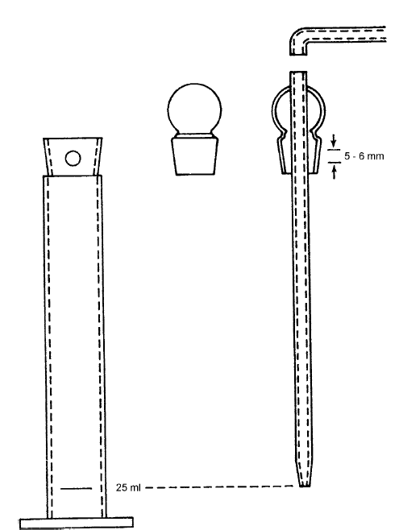
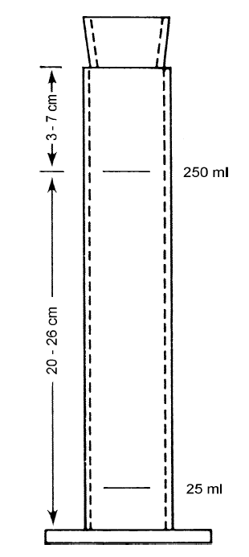
Fig 1: A 250 ml measuring cylinder for determination of suspensibility, showing special fitting for the removal of the top 9/10ths of the suspension. Left, mesuring cylinder with opening. Centre, plain stopper. Right, glass suction tube equipped with special stopper. The length of the tube should be such that when inserted in the cylinder the tip is exactly at the 25 ml graduation. The special stopper has a hole of 5 to 6 mm diameter, which should coincide with the hole in the cylinder neck when the suction tube is in position.
Fig 2:
Alernatively an U-shaped metal suction tube with an internal diameter of about 2-3 mm can be used. The length of the tube should be such that when the tube reaches the bottom of the cylinder exactly 25 ml of suspension remain in the cylinder.

